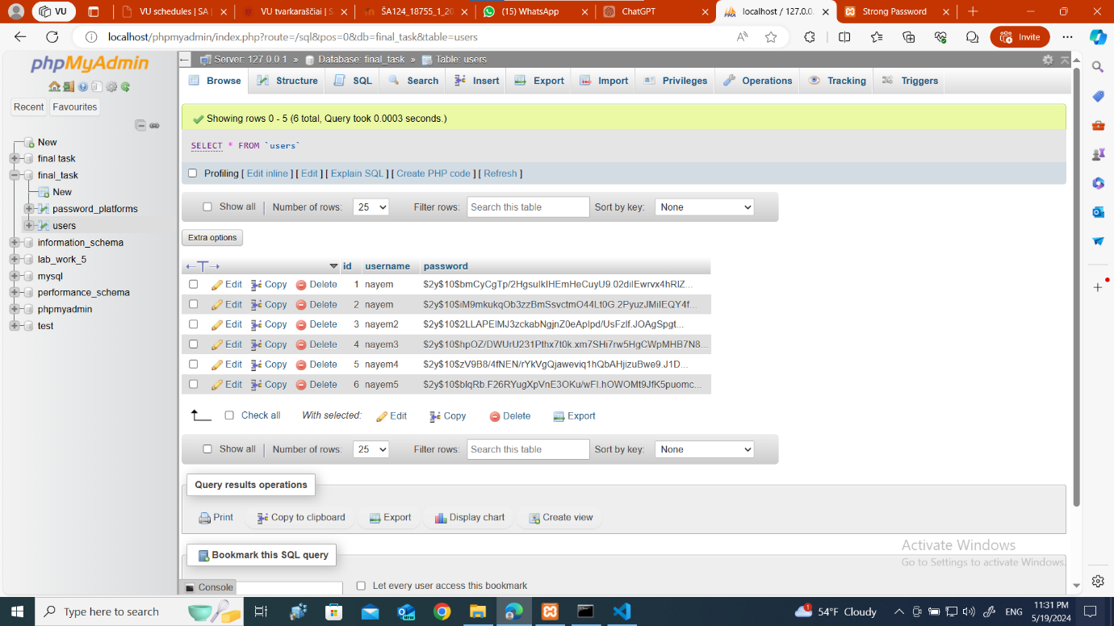
My database has two table one is users and another is password_platforms.
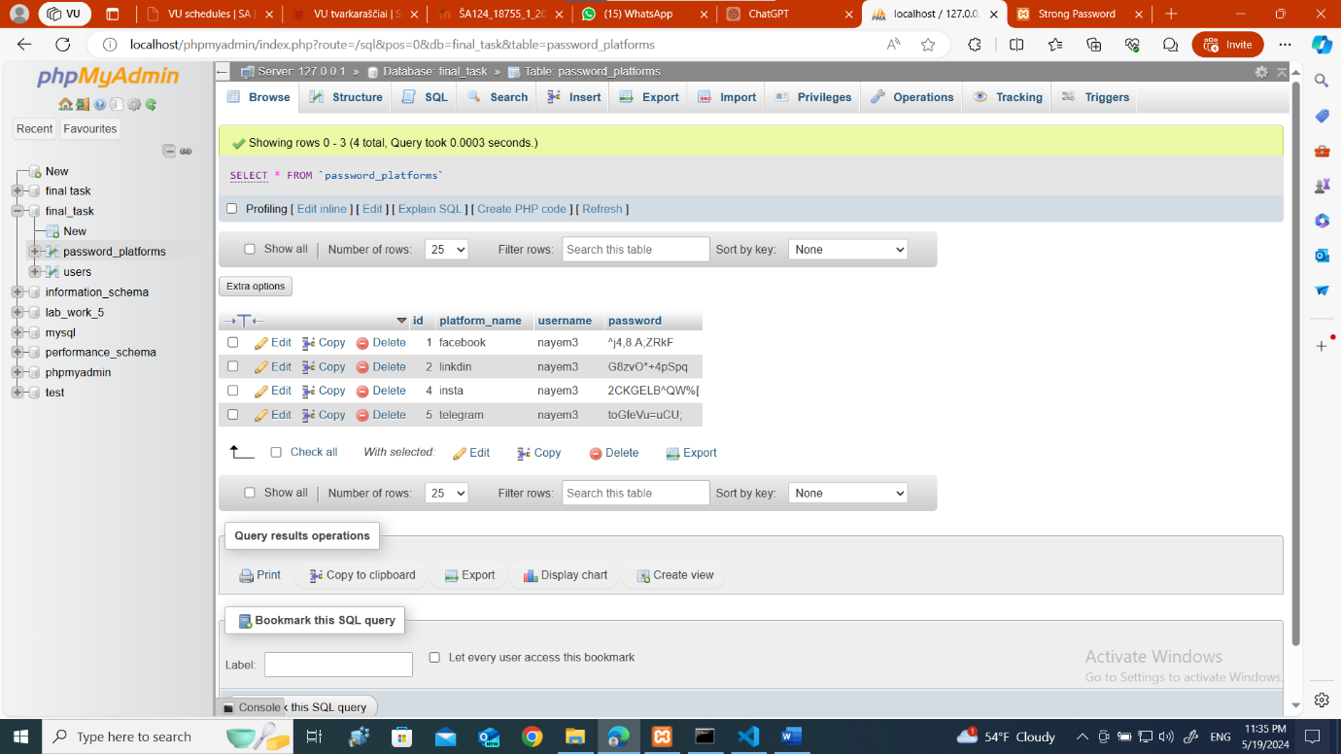
These are some of my testing data.
Now I will go through all the code and explain.
- First is the sign-up page. I copied the css design from my crud task. This is how it looks .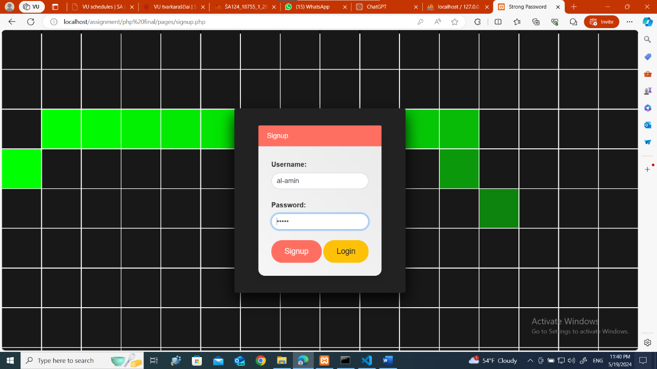
When I clicked the sign up button his user name [al-amin] will be stored in the database and a new user will be created.
- After creating a user we can log in with that user .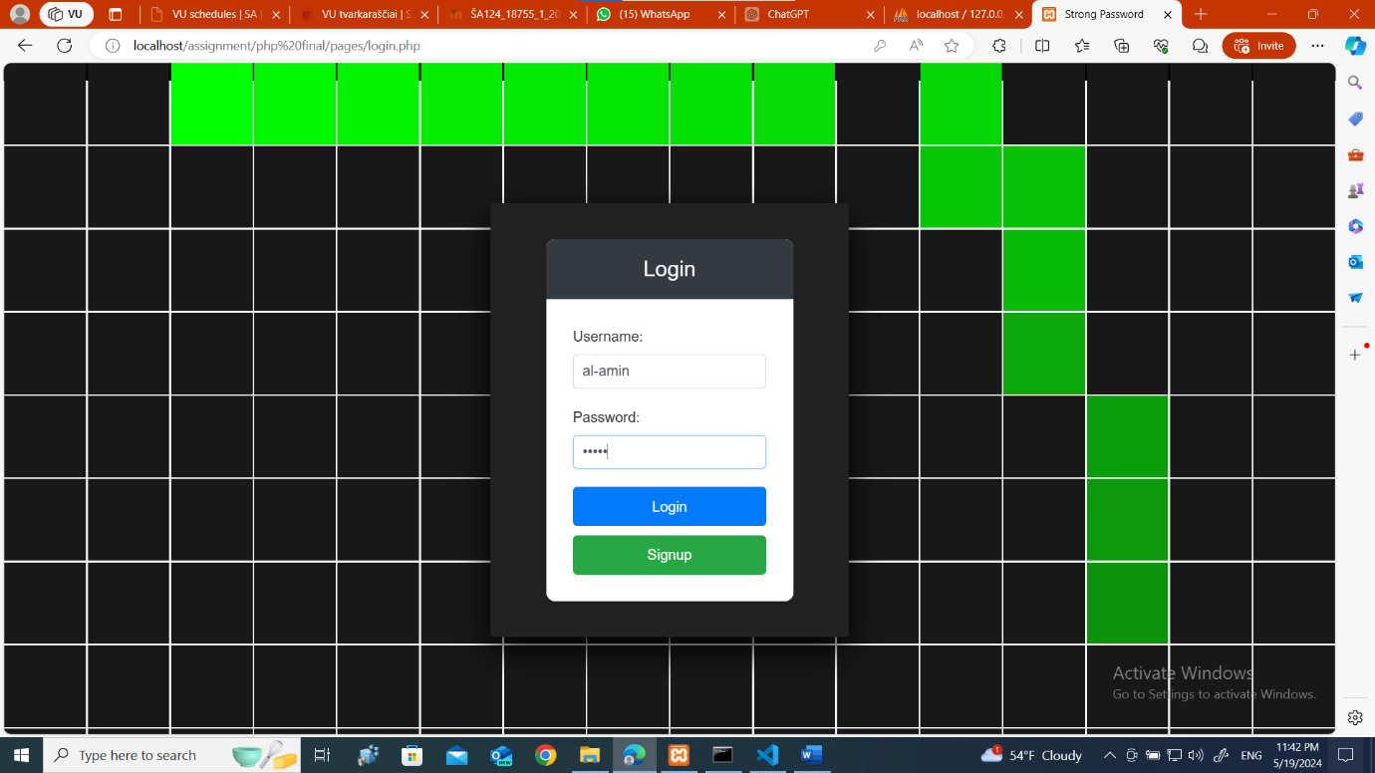
- When log-in we can see the user who is loged in . it will show at the top and we can also add any account and generate password buy clicking generate password.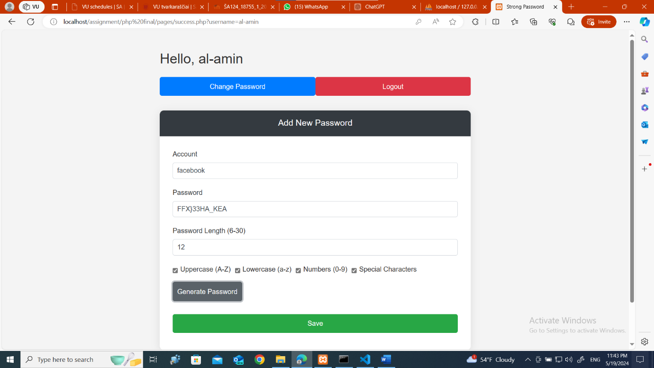
We can also create password by ourself . when we click save it will store inside data base and also show bellow.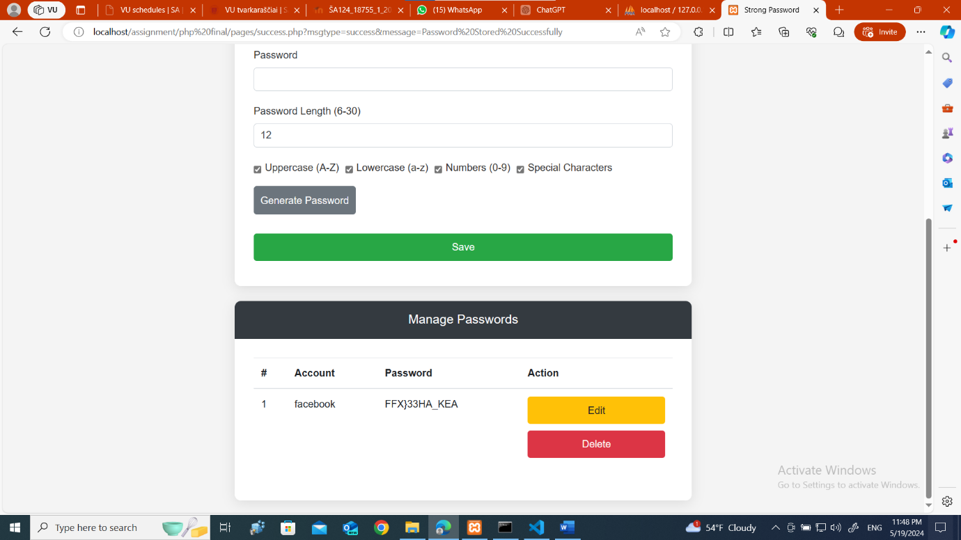
Also we could remove the checklist to like this.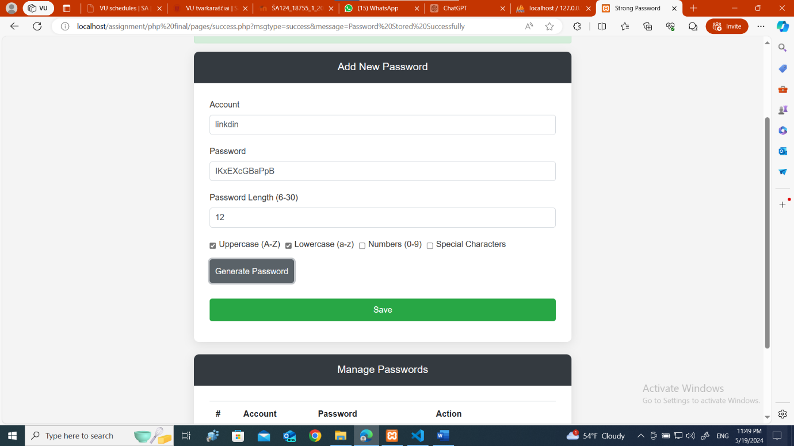
We could also edit and delete the password from the password manager.
- When clicked the edit button it shows the previous saved data and we can change the password and also the name.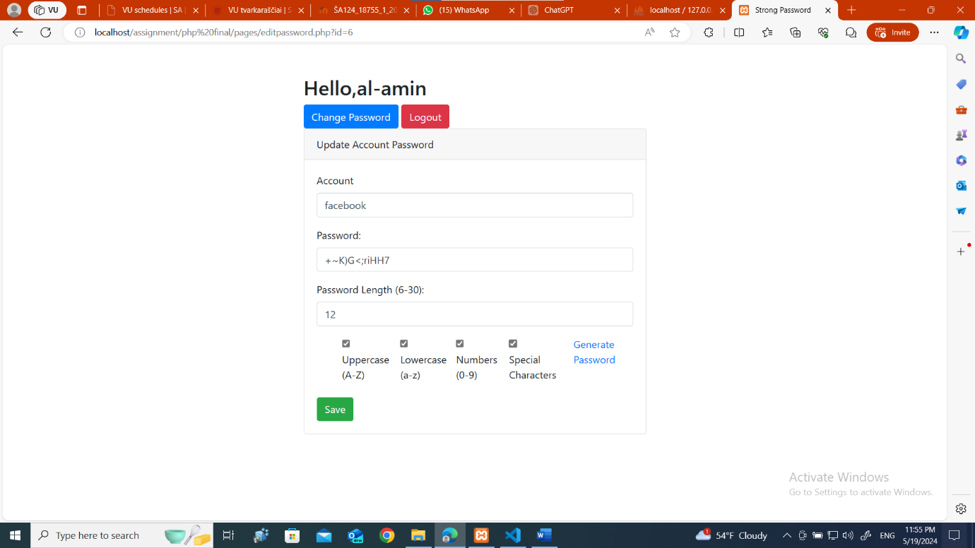
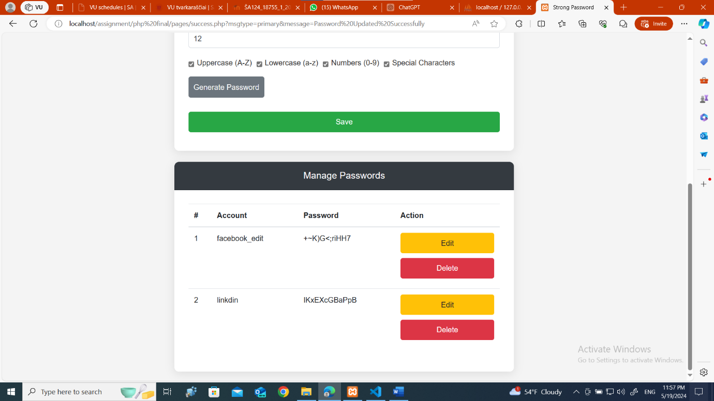
- If clicked in delete button it got deleted.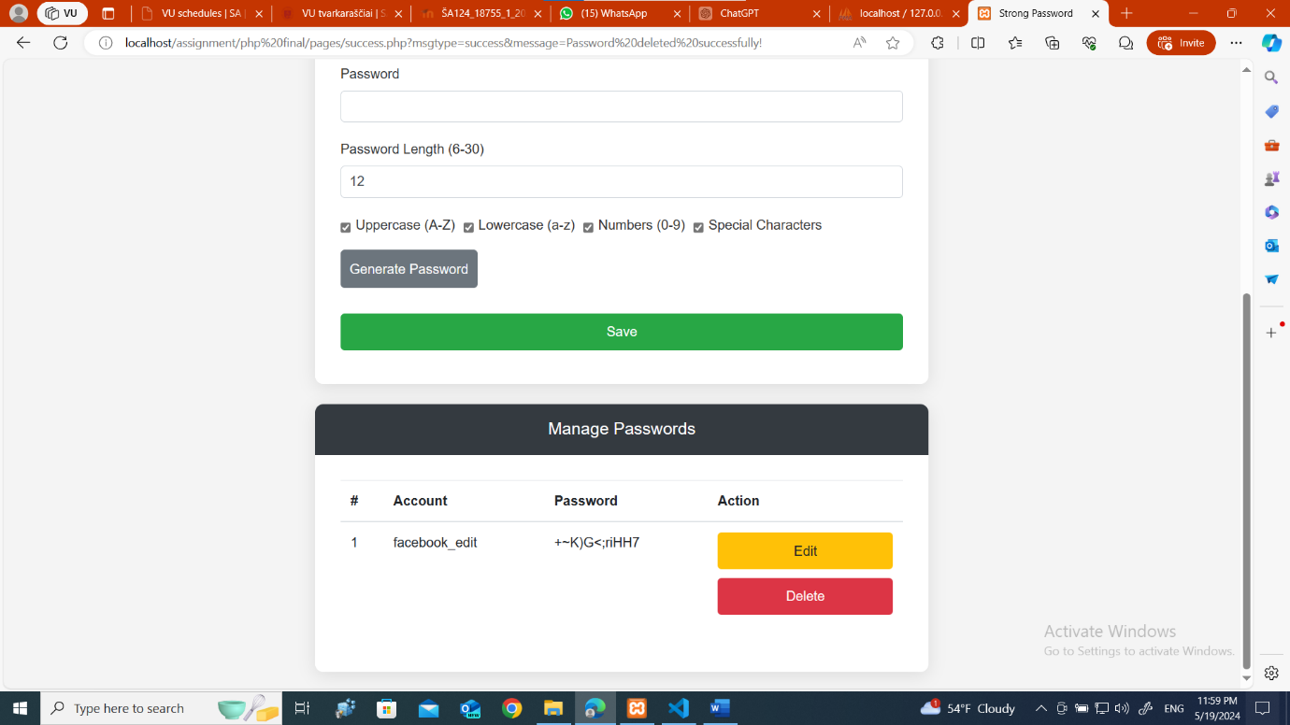
We can also change password of the user and also log out .
- When clicked in change password we can change the user password who is currently loged in.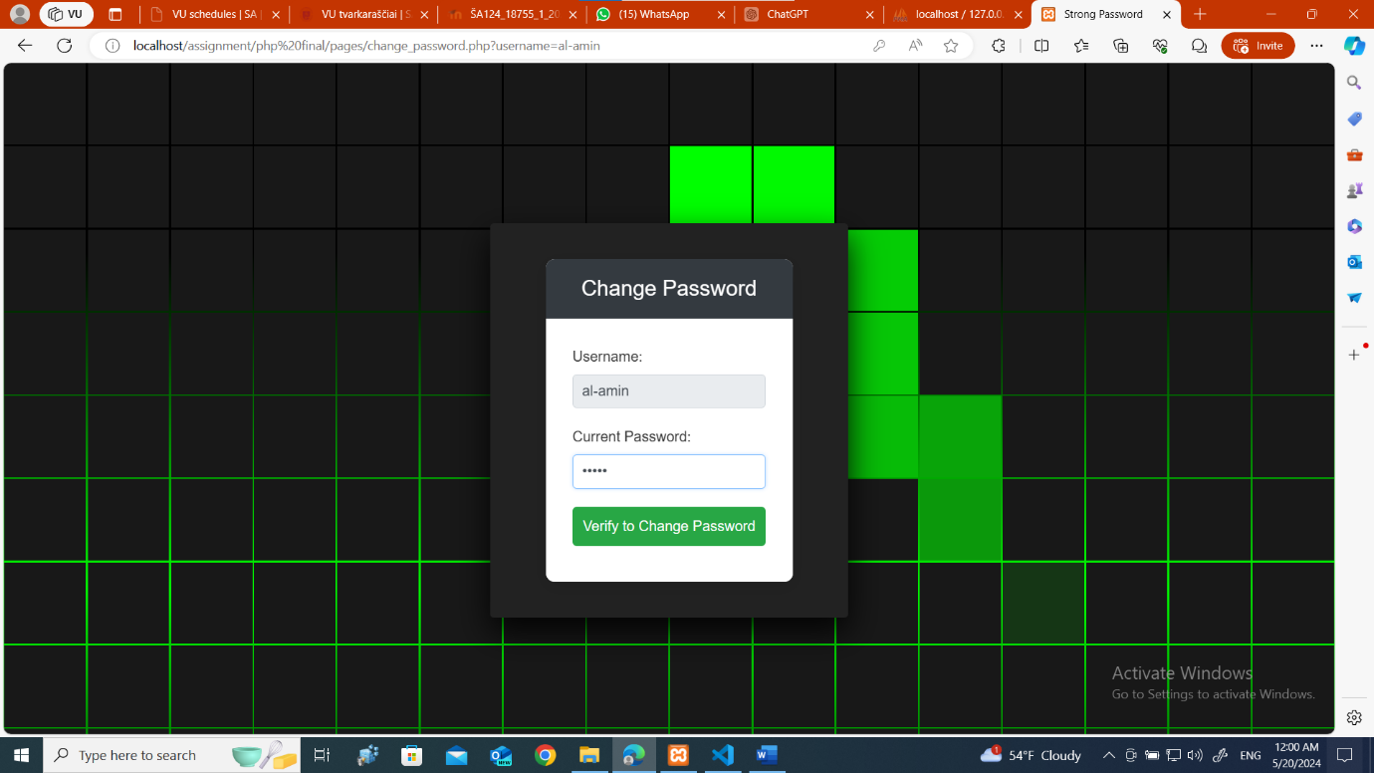and if we provide the wrong information a modal will pop up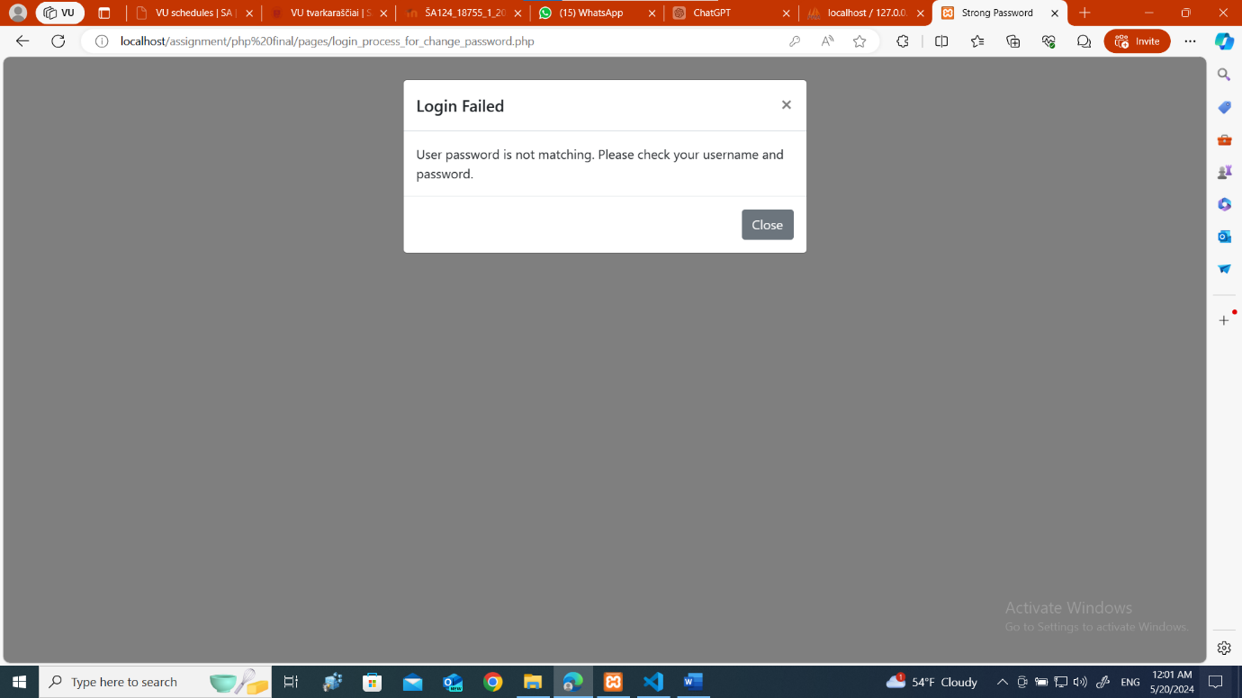if we provide the correct password a new window will pop up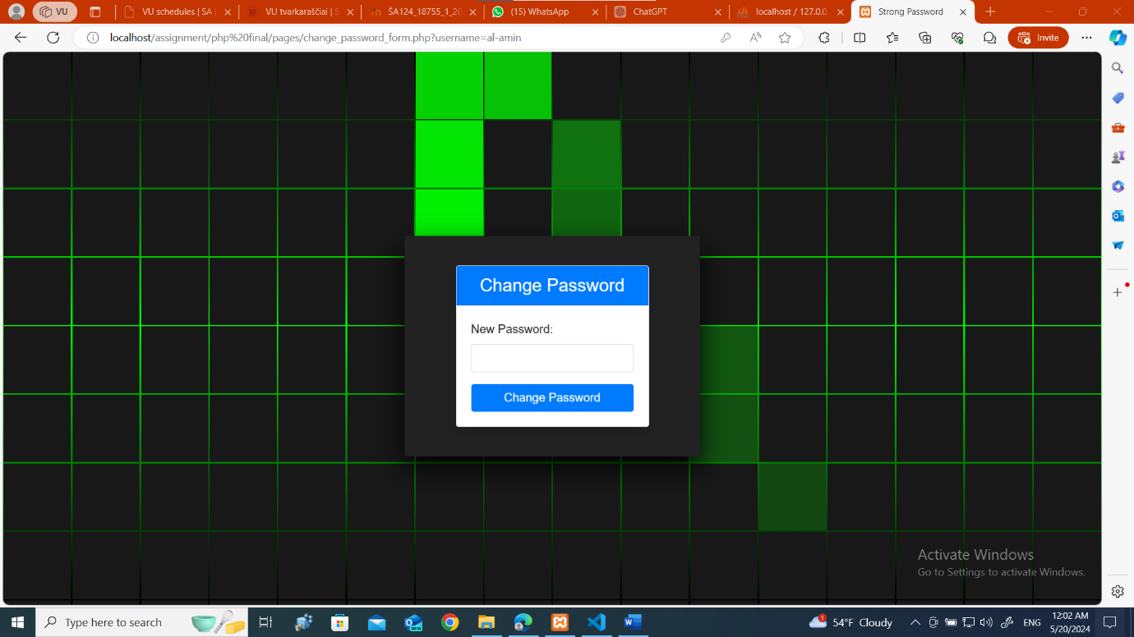and we will change our password.
- When we click in the log out button it will redirect to the log-in page again .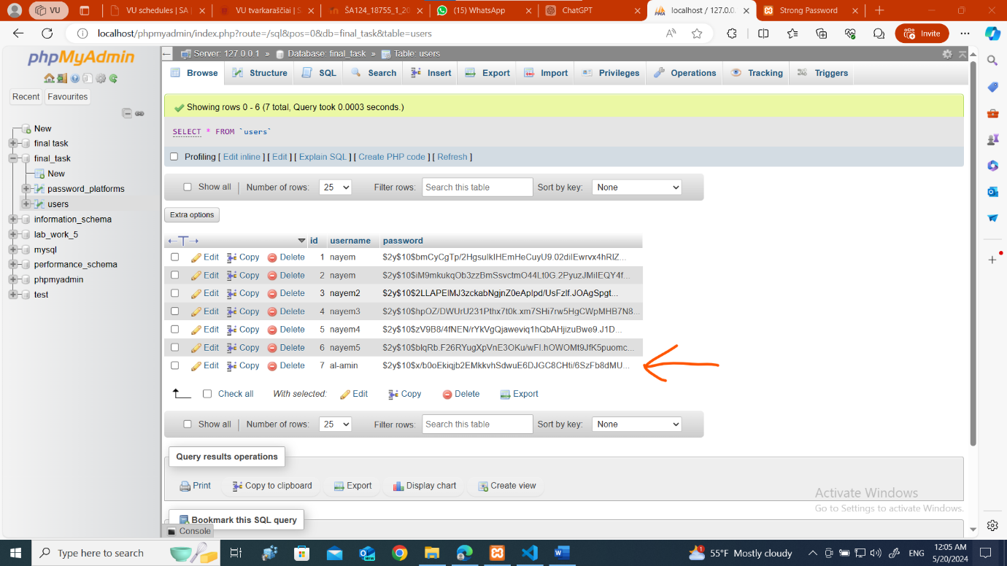
New user is added in the database the one I use for the report.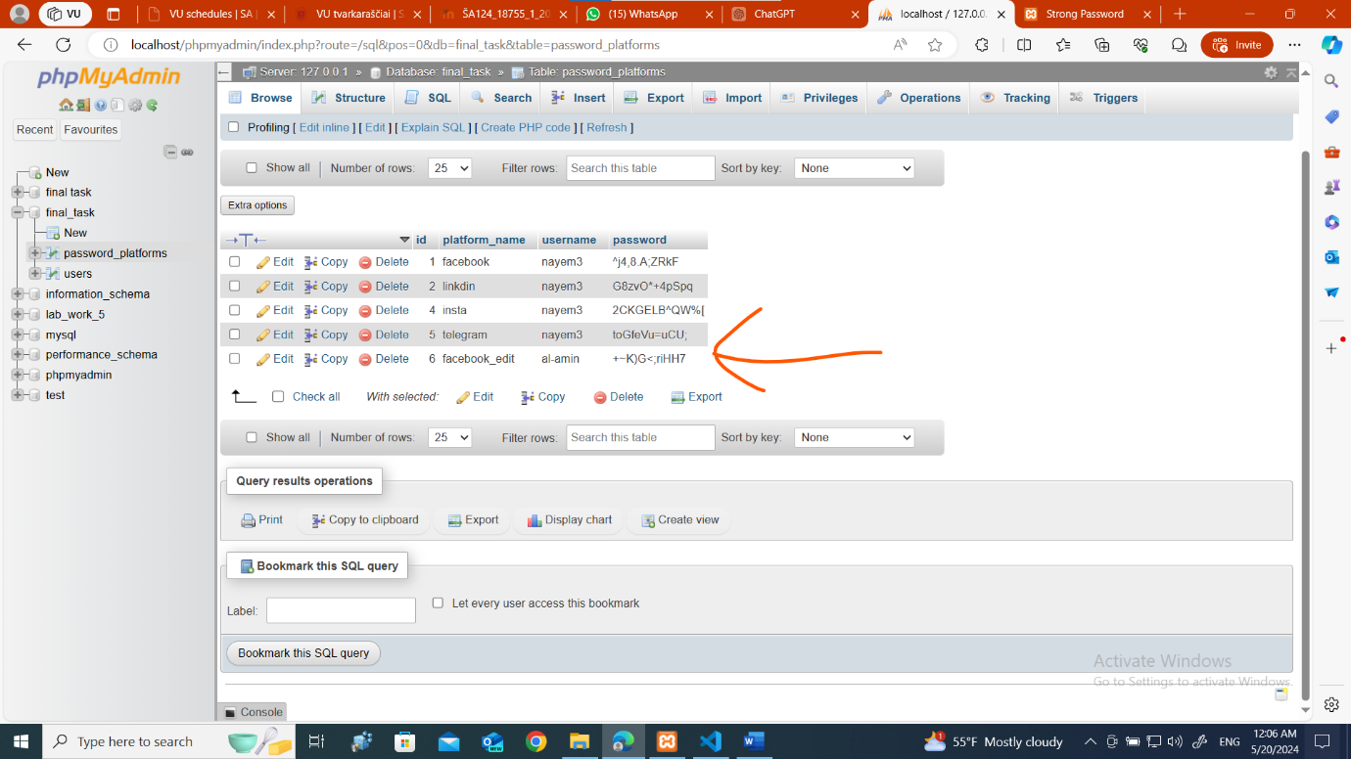and the new platform password that I create for demonstration its also added to the database.

That’s all for my report….

